Date: ______________
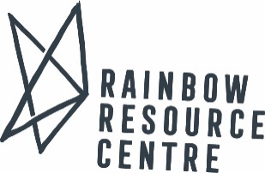
SEIC VIRTUAL GSA VISIT REQUEST FORM

Name: __________________________________________ Position/Title: ____________________________________

School and/or Group: _______________________________________________________________________________

Address: __________________________________________________________________________________________

Phone Number: ___________________________ Email: ___________________________________________________

Please tell us about your group. GSA name? How many years together? New members? Feel free to share whether the request is in response to an incident or if anything has happened for the group to want to address.

Please tell us about the audience for the workshop. What ages/grades, students/teachers, etc.?

Please tell us which topics or areas of interest you are hoping to learn/gain knowledge. How to virtually meet, gain members, activities, promotion, programming, fundraising, goal setting, history, attractions and identities, etc.:

Number of attendees expected: _______

2SLGBTQ+ Level of knowledge of participants (please check all that apply):
□ Not a lot of knowledge □ Basic knowledge □ Fairly Knowledgeable
□ Other comments:

Please provide proposed dates for your session. It is helpful if more than one date is proposed. Suggested length or time. (minimum of 2 weeks notice to accommodate most requests):

Financial:
□ GSA Visit – no fee required. Honorarium suggested.

There may also be an additional/charge for workshops outside of Winnipeg.

If you would require a receipt for an honorarium, please indicate the amount: _________________________________

Other comments or questions:

Please email this form to: deneg@rainbowresourcecentre.org

Should you have any questions please call 204-474-0212 ext. 203 or email deneg@rainbowresourcecentre.org

